* **ASSIGNMENT_1 OUTPUTS**
* **HOME PAGE:-**

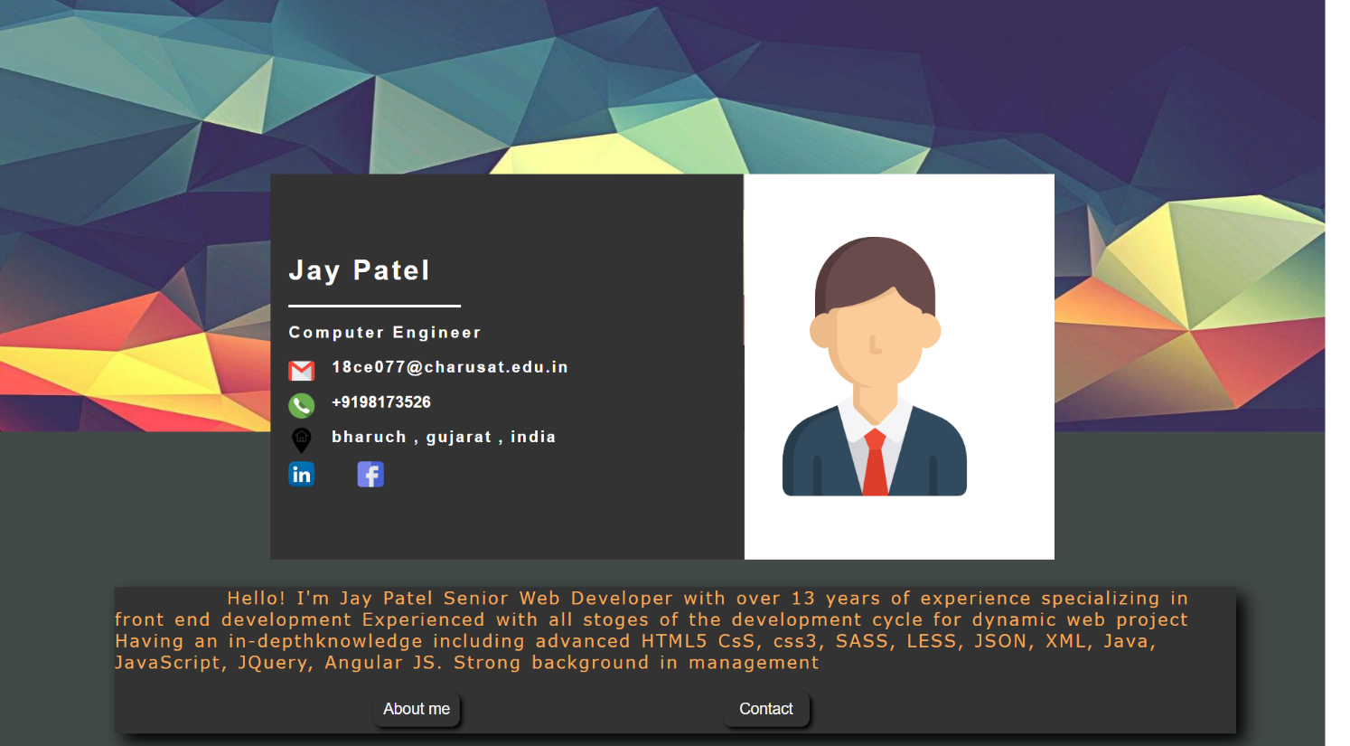

* **Bio-graphy_page1:-**



* **Bio-graphy_page2:-**

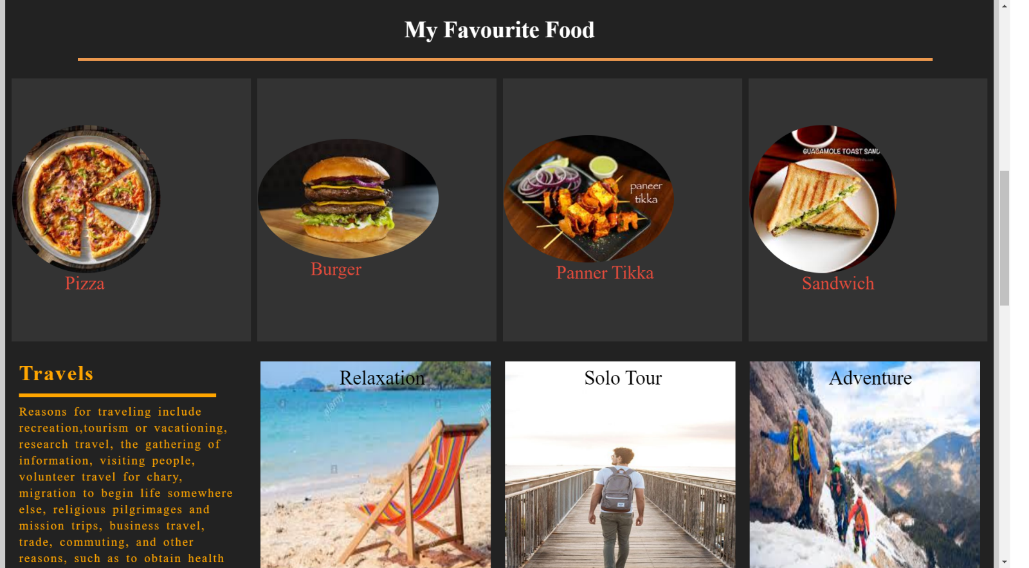

* **Bio-graphy_page3:-**

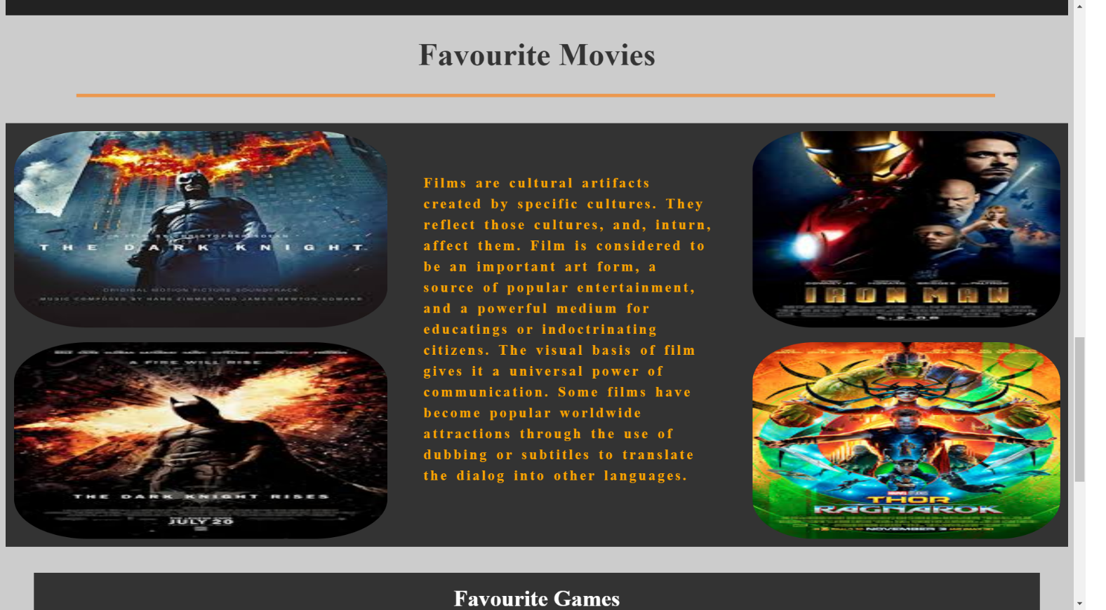

* **Bio-graphy_page4:-**

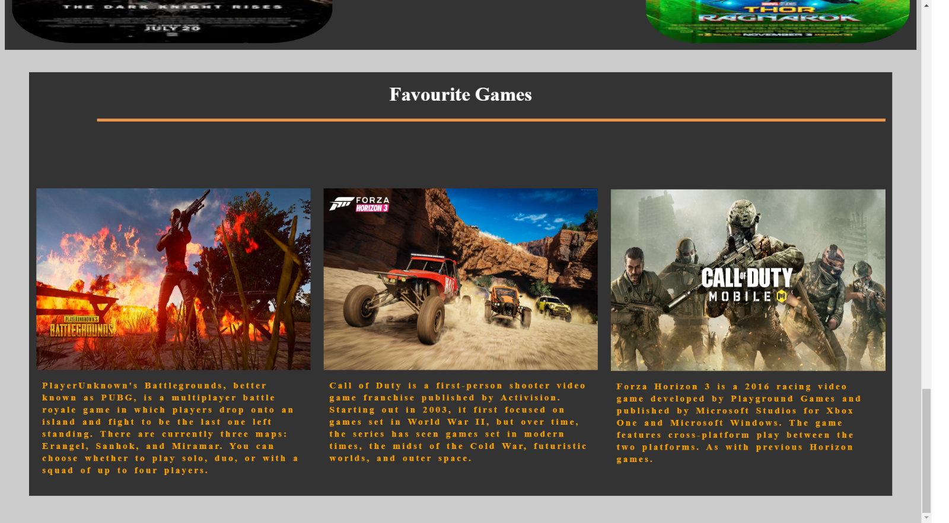

* **ASSIGNMENT_2 OUTPUTS**
* **Output_1:-**

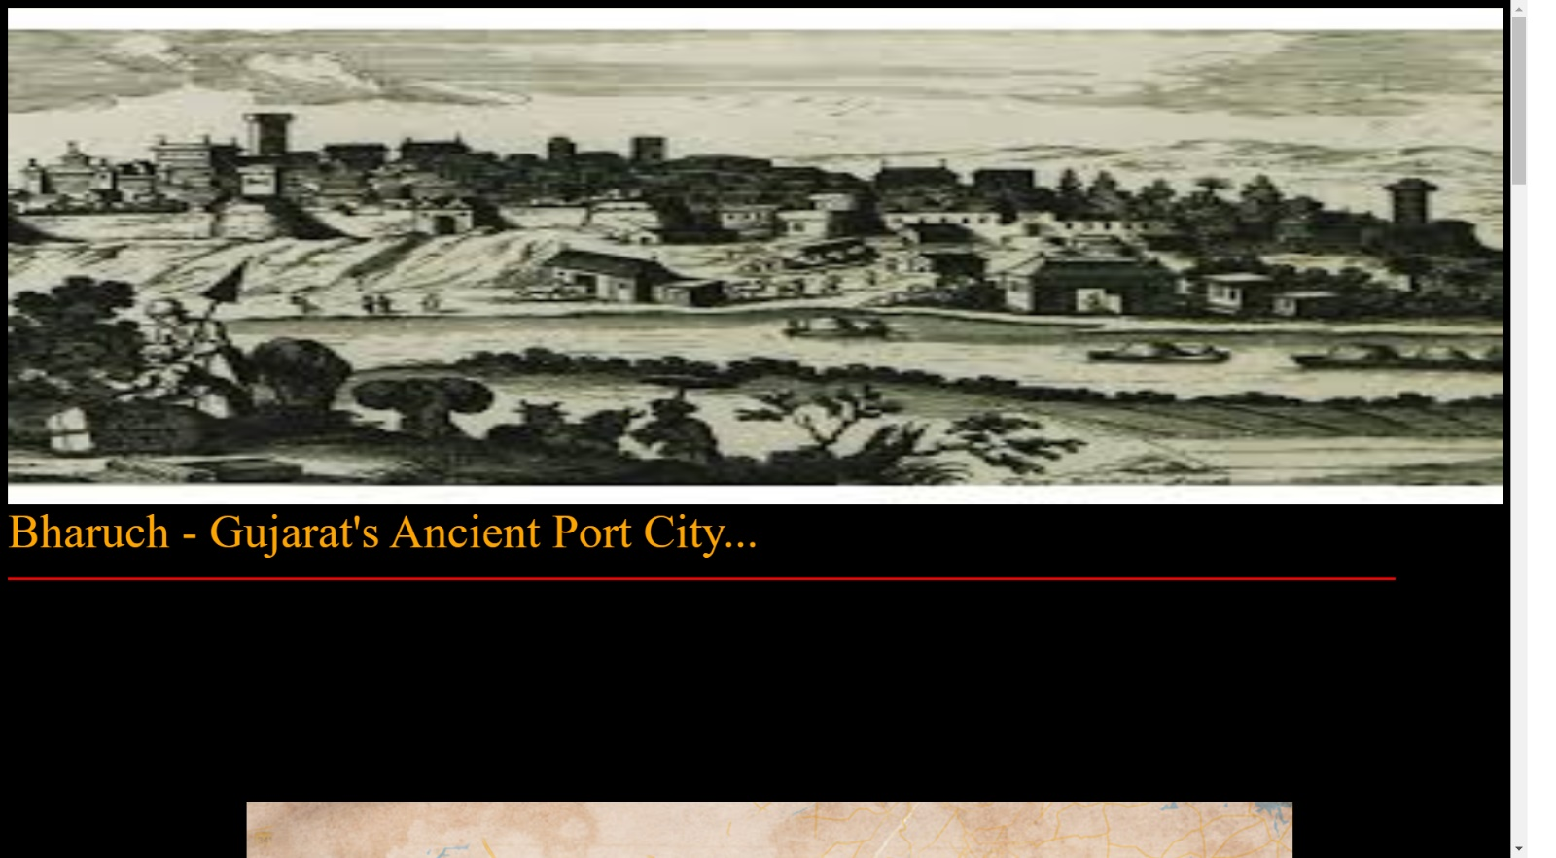

* **Output_2:-**

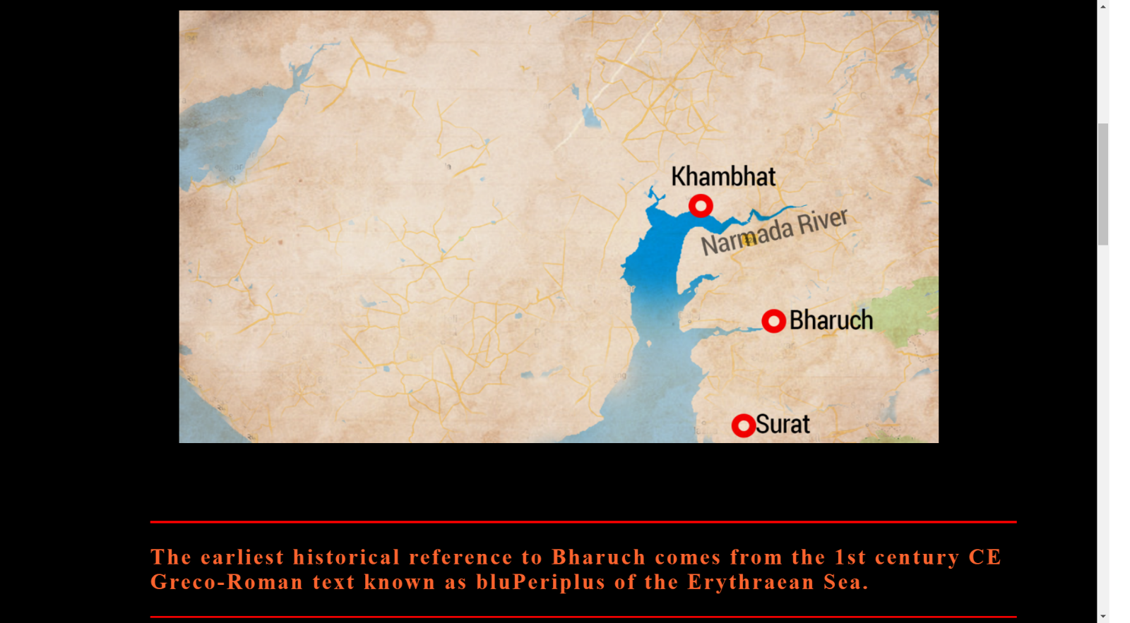

* **Output_3:-**

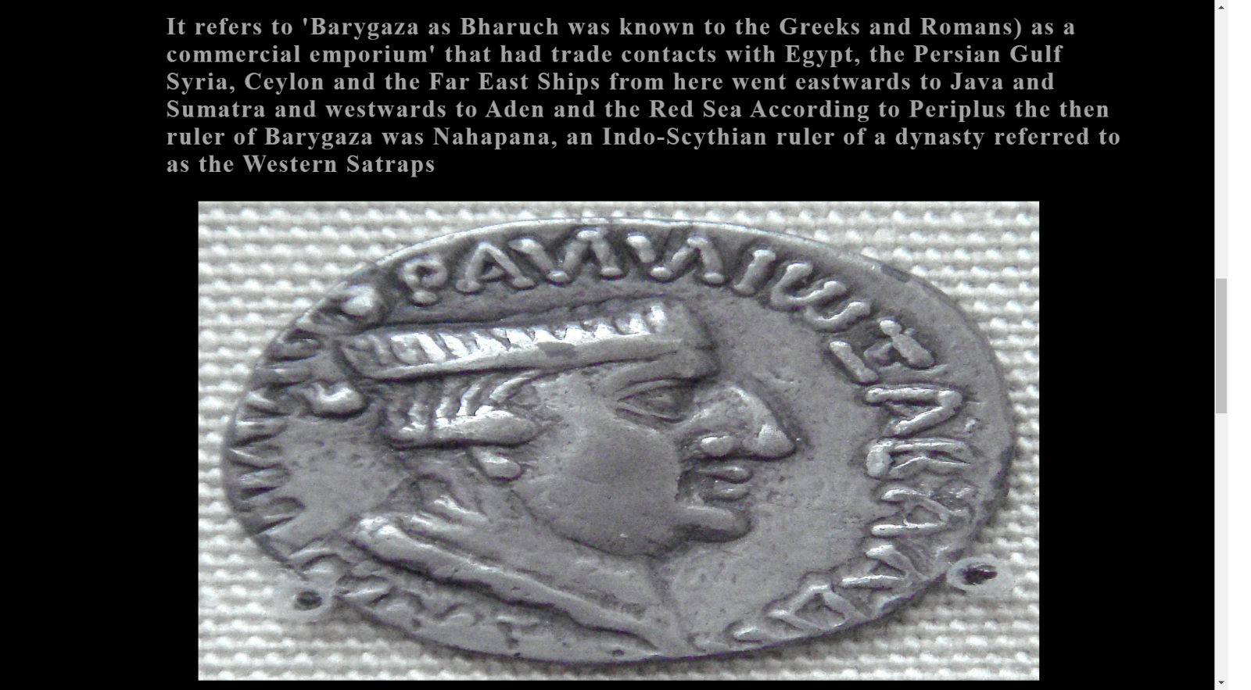

* **Output_4:-**

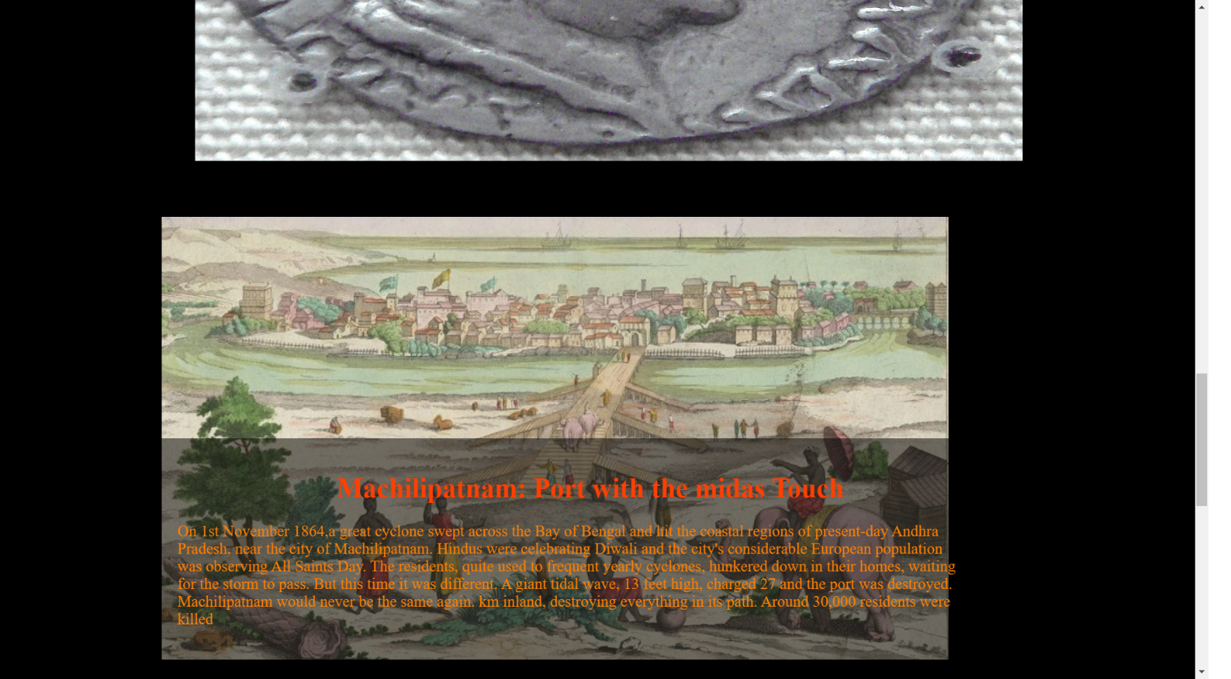

* **Output_5:-**

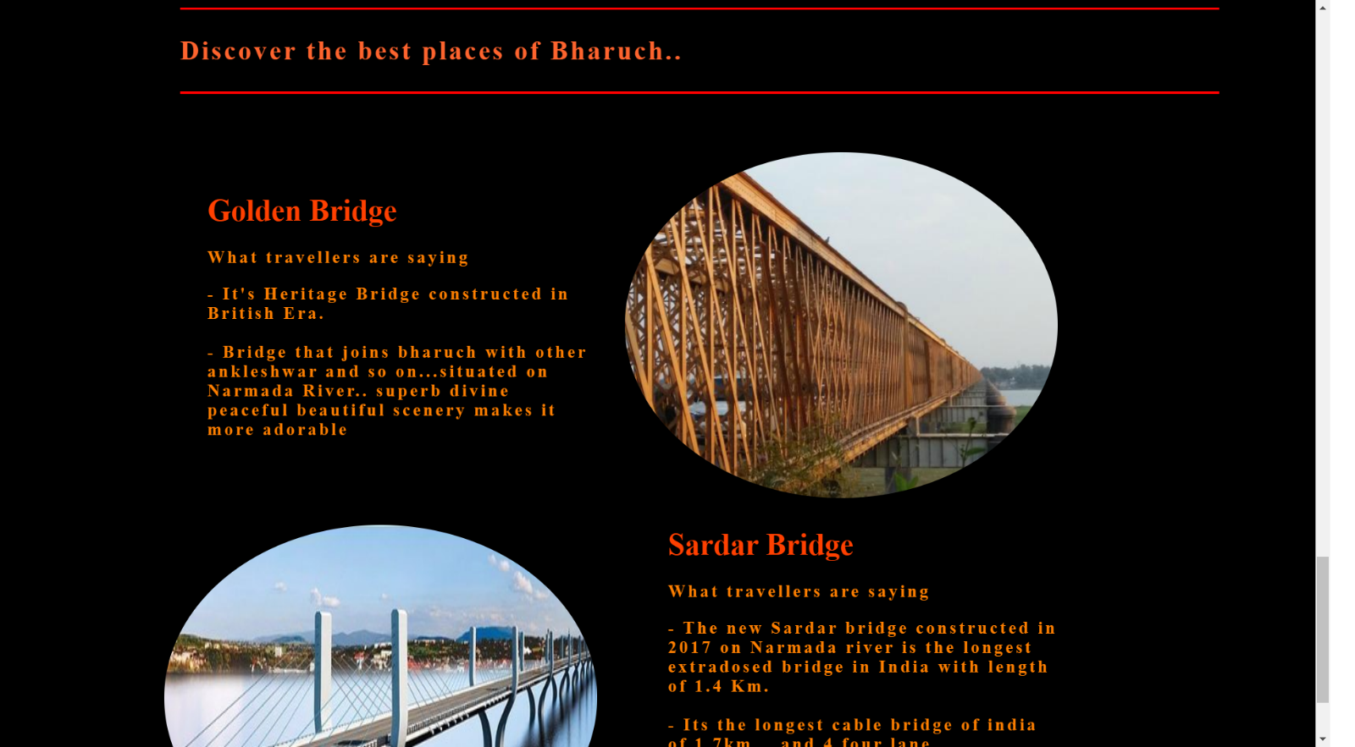

* **ASSIGNMENT_3 OUTPUTS**
* **Alert_page:-**

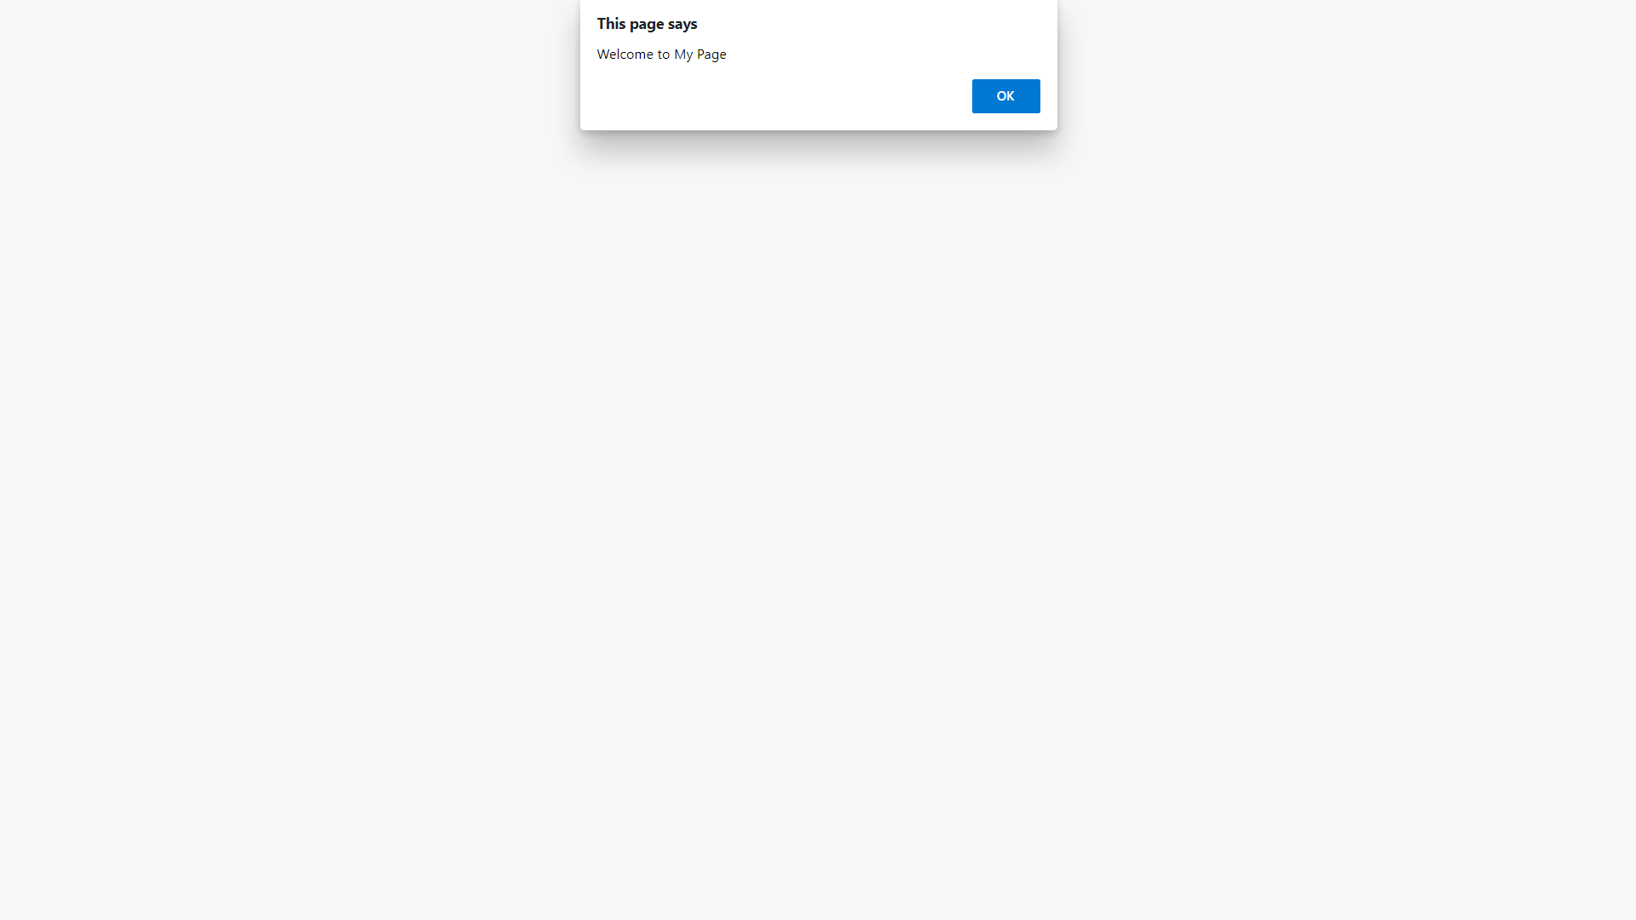

* **Home_page:-**

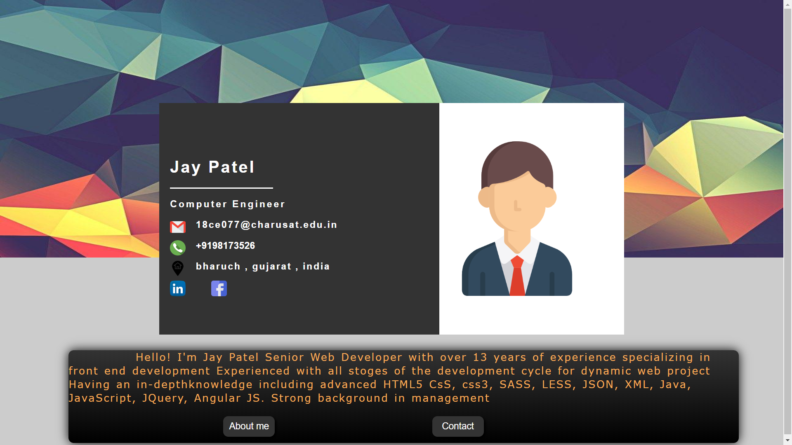

* **ASSIGNMENT_4 OUTPUTS**
* **Registration_form:-**

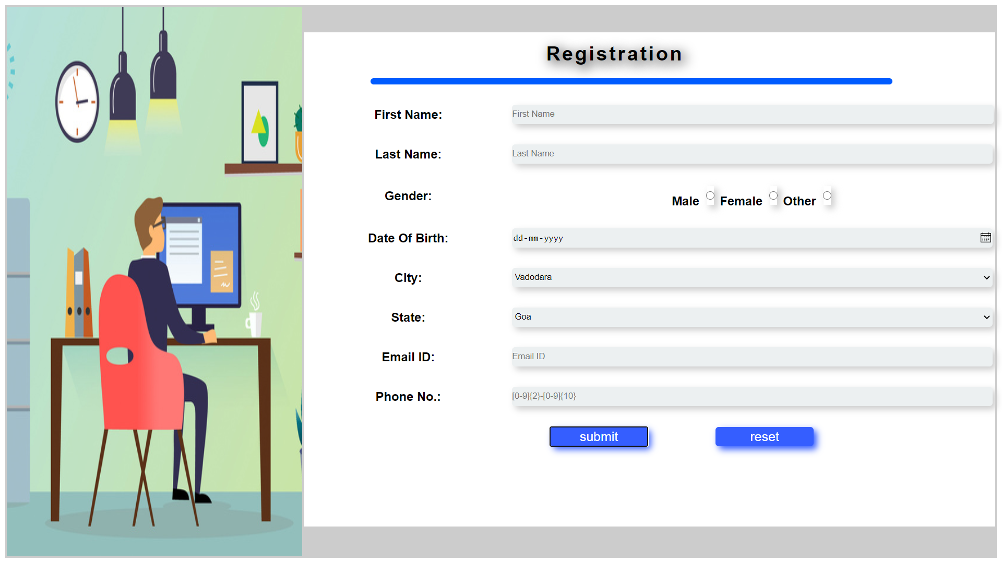

* **ASSIGNMENT_5 OUTPUTS**
* **Work-shop Registration form:-**

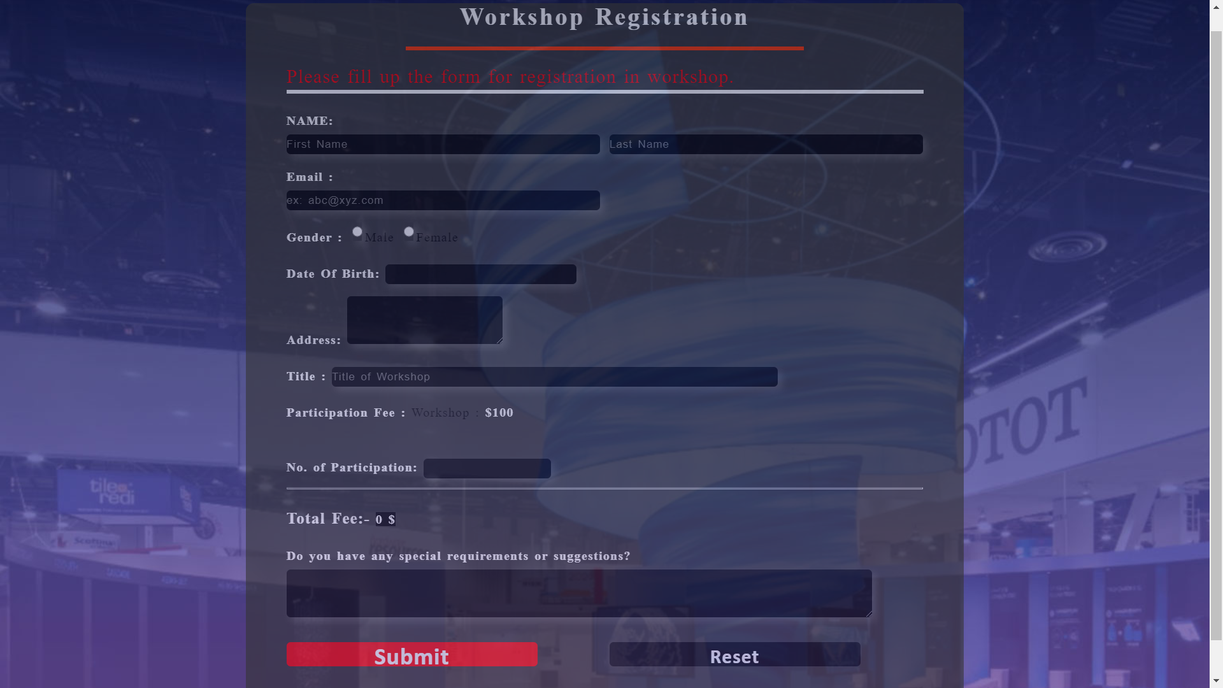

* **Data entry in Database:-**

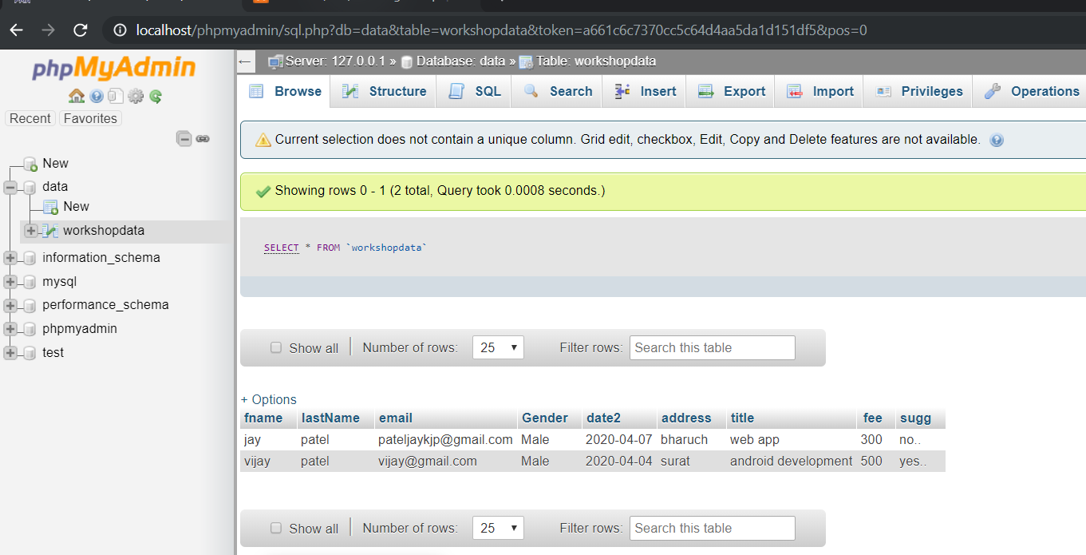

* **ASSIGNMENT_6 OUTPUTS**

